WE930

GPS VEHICLE TRACKER

USER MANUAL

V2.0

Product overview
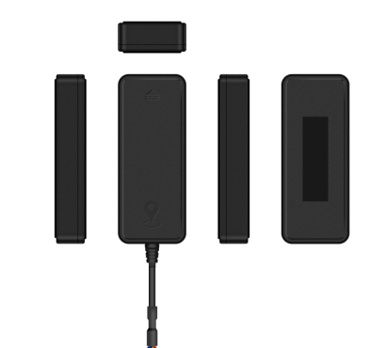

·Real-time tracking
·Driving behavior analysis
·Over-speed alert
·Removal alert
·Power-supply-cut alert
·Low power alert
·Vibration alert
·Geo-fence
·SOS
·pickup

Standard Parts List

Item |  |  |  |  | Quantity
WE930 |  |  |  |  | 1
Power cable |  |  |  |  | 1
Relay |  |  |  |  | Optional
Specification
Network |  |  |  |  | 4G/LTE (Cat.1) & 2G
Indication |  |  |  |  | Power (Red)  GSM (Green)  GPS (Blue)
Built-in battery |  |  |  |  | 300mAh
Measurements |  |  |  |  | 80*32*15.1mm
SIM Card |  |  |  |  | Micro SIM
Operating temperature |  |  |  |  | -20°C to +70°C

Product Setup
- Prepare a Micro SIM card that supports the same network with this device.
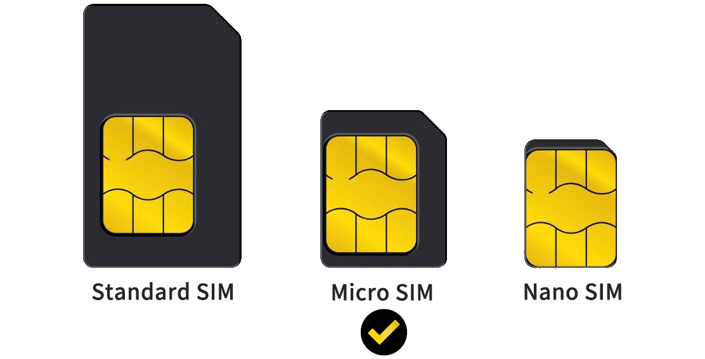

- Slide the device cover up to open it.
LED Indication

All indicators work for 3 minutes after power on and automatically enter sleep mode when static. Vibration will wake up the indicators again.

Red LED -Power status
Solid bright | Normal working  (External power supplying)
Off | Power off

Green LED -GSM status
Slow flashing | Searching Network
Solid bright | Normal working with GSM network
Off | No SIM card inserted or dormant

Blue LED -GPS status
Slow flashing | Searching GPS signal
Solid bright | Normal working with GPS fixed
Off | Dormant

Interfaces
4 Wire Standard Version
Interface | Color | Description
B+ | Red | Power + (9-90V)
GND | Black | Power -
ACC | Orange | Vehicle ignition detection
Relay | Yellow | Vehicle fuel supply cut-off

Wiring Diagram
Tips for finding right wires:
- Use a multimeter to identify the positive and negative terminals of the vehicle battery.
Note: The current battery voltage will be displayed on the multimeter regardless of whether the ignition key is in the ON or OFF position.
- To locate the ACC wire: Connect the black probe of the multimeter to the negative terminal, and the red probe to a random wire. If the multimeter displays 0V, turn the ignition key to ON. If the supply voltage appears, you have identified the correct ACC wire.
- Connect the two connectors together. If the vehicle does not have a connector, connect the device wires to the corresponding vehicle wires.

Installation recommendation
Please install the device under the guidance of professional personnel.

Note
- The device should side up to sky.
- Metal thermal barrier or heating layer, which are always installed on windshield, may affect the signal, please avoid installing the device under these objects.
Troubleshooting
Type | Use
Unable to connect to platform | Check APN and IP settings  Check whether the data of SIM card is enabled  Check SIM card balance
Tracker shows offline on platform | Check external power is still connected  Check if the vehicle entered network blind area  Check the balance of SIM card
Unable to locate | Make sure the top side facing upward without metallic things shielded  Make sure area with satellite coverage
Location drift | Area with poor GNSS signal, drifting may happen  Check whether vibration happens around to trigger the accelerator
No command reply | Make sure command format is correct.  Device must be in network coverage area  Make sure SIM card inserted well and with SMS service

